31.33: a) 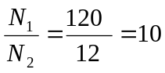.
b) 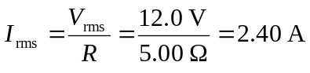

c) .
d) 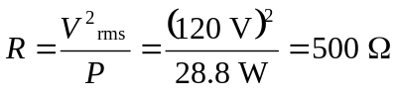, and note that this is the same as


